FRENCH

IN FRENCH WE ARE LEARNING DIRECTIONS AND PLACES FOR EXAMPLE LE CHATEAU WHICH IS A CASTLE AND A DIRECTION IS ALLEZ TROUT DROIT which means go forward.

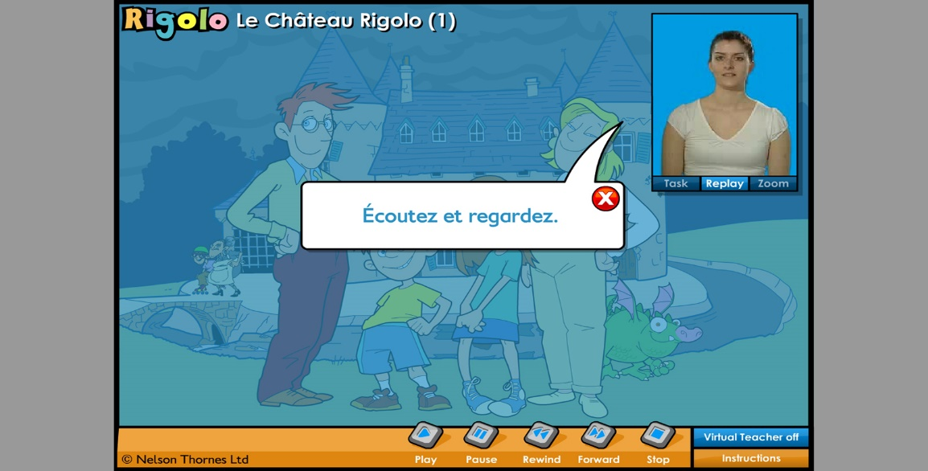

The subject that we are doing is called EN VILLE.