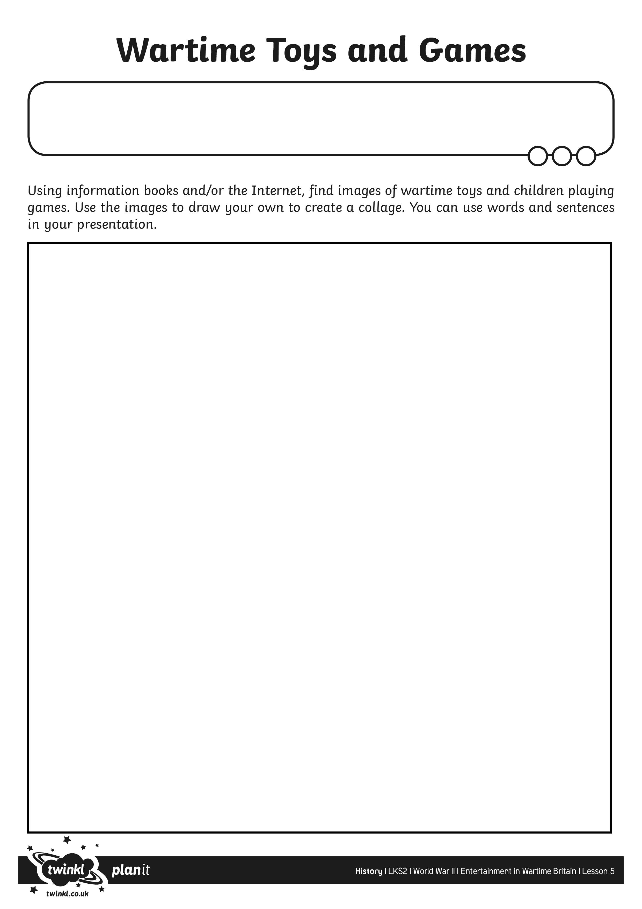
I can create a collage of wartime toys and games.

