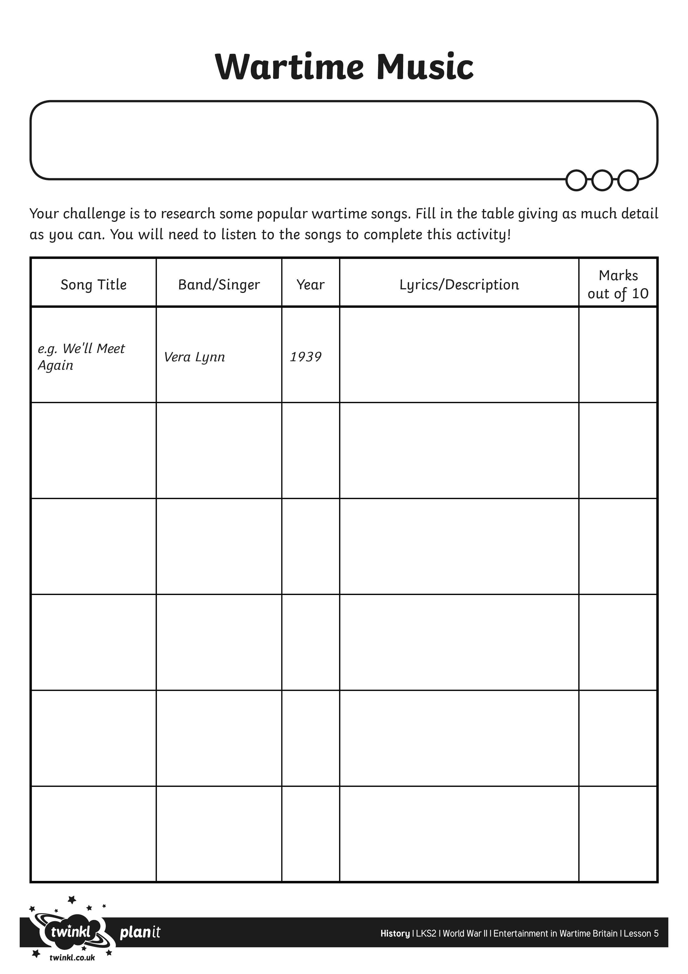
I can research and present information about some popular wartime songs.

