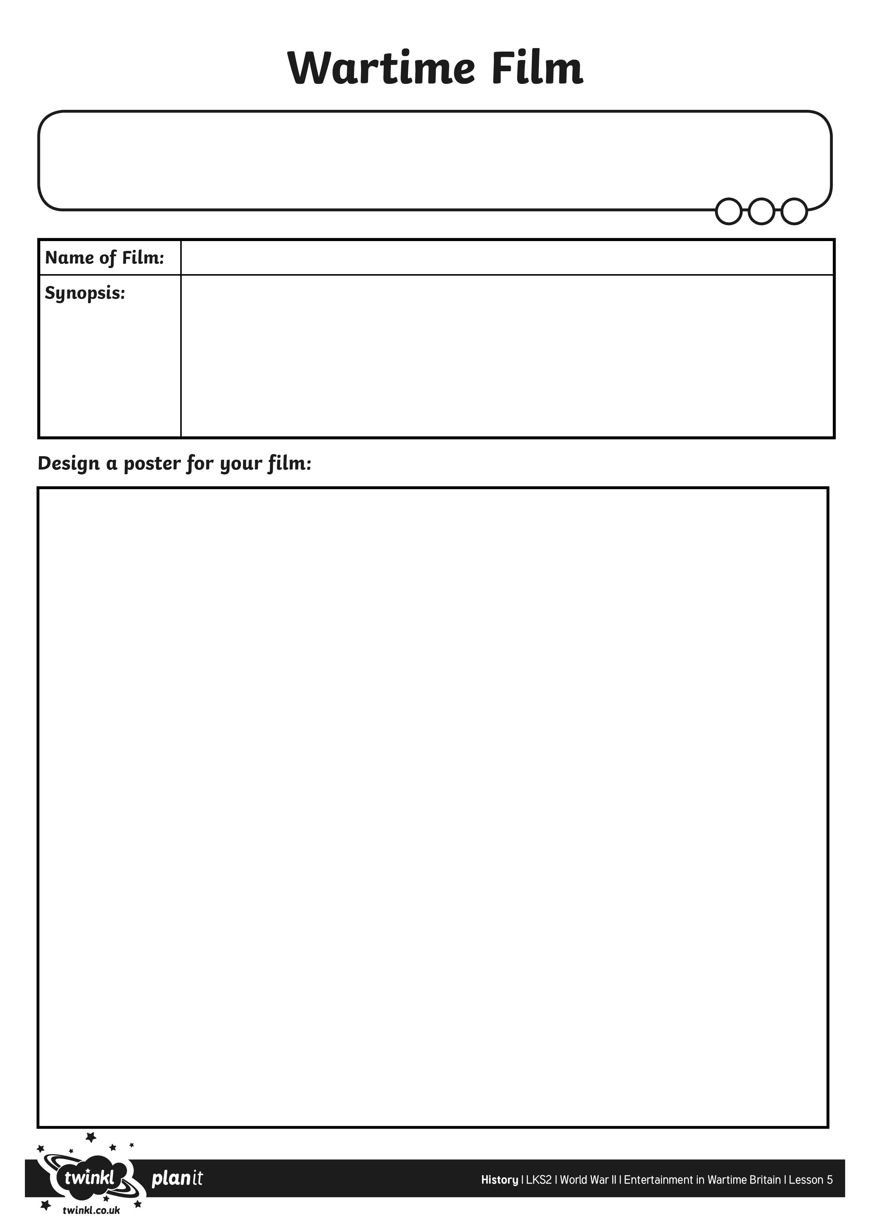
I can write a synopsis and make an advertising poster for a wartime film.

