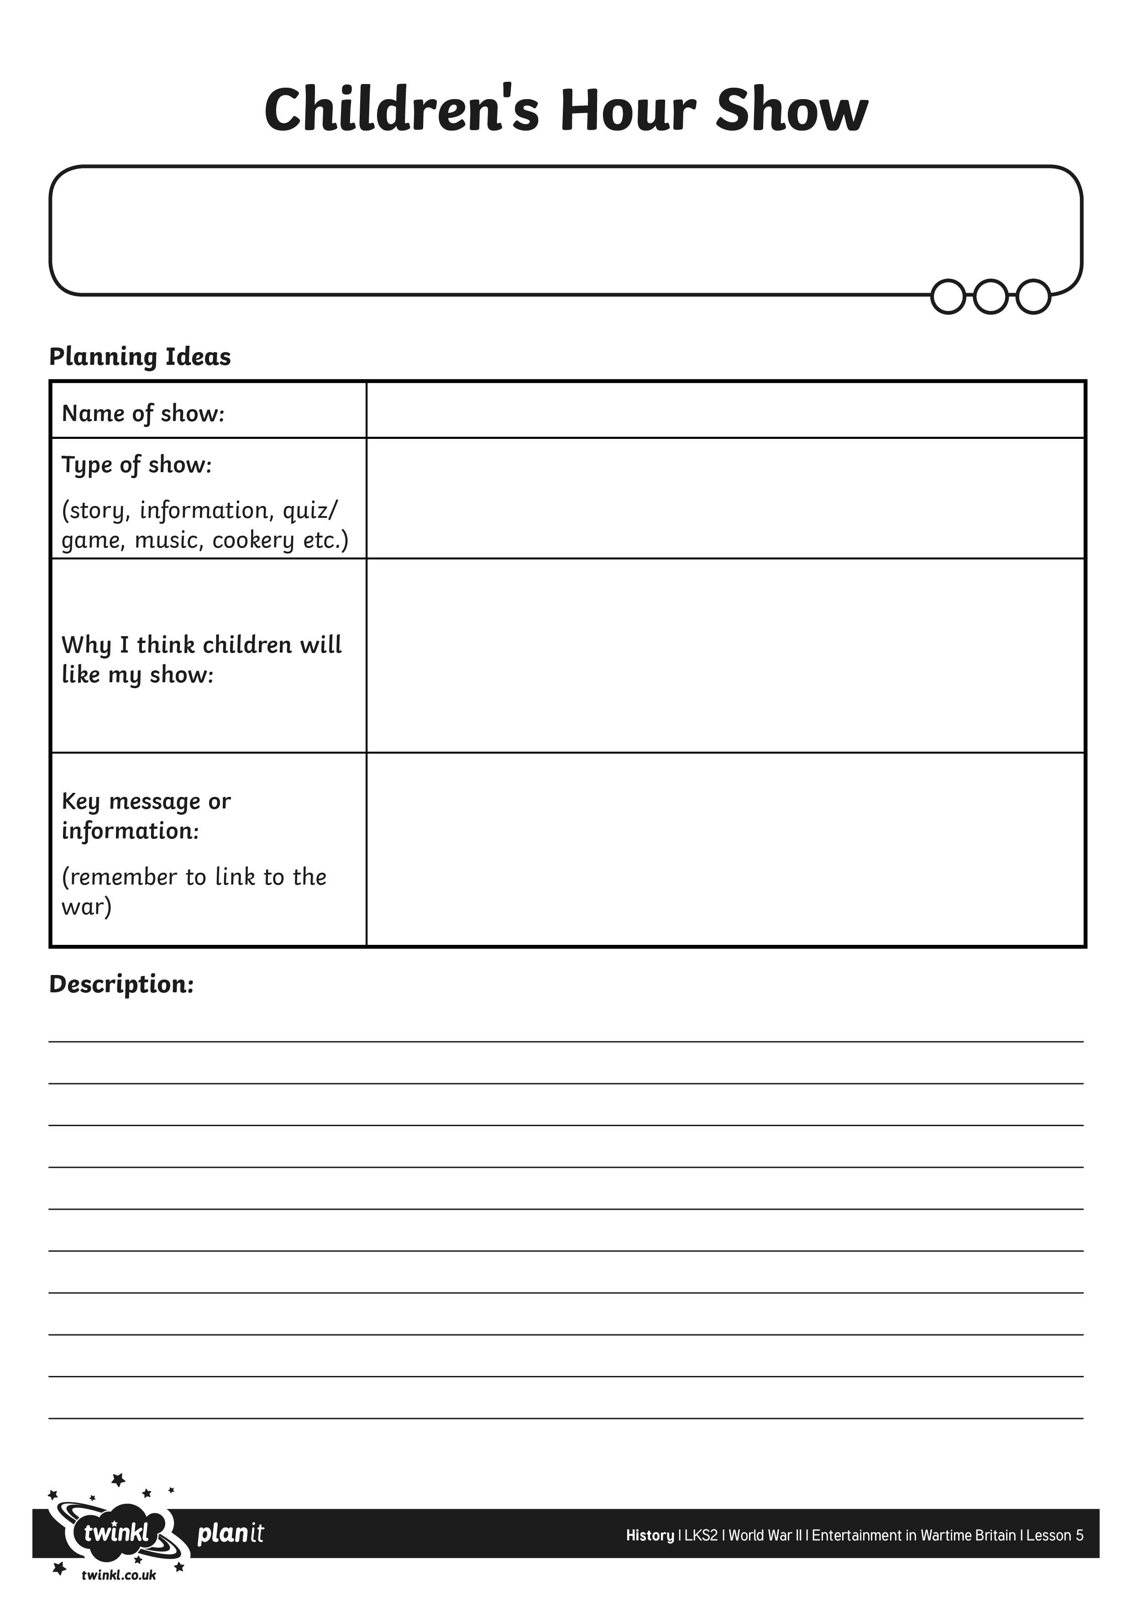
I can devise my own wartime radio show.

